getting started with SPARX4EDGY23
  - EDGY23 MDG for sparx enterprise architect
Rudi Claes
rudi.claes@inno.com

Management summary
EDGY is an open Source tool for collaborative Enterprise Design. SPARX4EDGY23is available as a free extension (MDG technology) for Sparx Enterprise Architect. This article shows how to install SPARX4EDGY23 and to create a sample viewpoint.

Table of contents
SPARX4EDGY23 – INSTALLATION 2
SPARX4EDGY23 – CREATING A SAMPLE VIEWPOINT 4

OTHER RESOURCES
EDGY https://enterprise.design/wiki/Home
EDGY TOOLS https://enterprise.design/wiki/EDGY:Tools
EDGY23 EXAMPLES EDGY23.qea

SPARX4EDGY23 – INSTALLATION
The SPARX4EDGY23MDG technology file “EDGY23 MDG.xml” is present in the SPARX4EDGY23 distribution ZIP archive. After downloading and extracting “SPARX4EDGY23.zip” to a location of choice on your computer or shared drive, launch Sparx Enterprise Architect and apply the following steps:
- Select the Specialize tab on the ribbon, then click on the “Publish Technology” button and select the “Import MDG Technology” option.
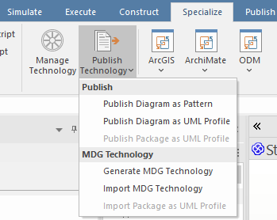
- On the “Import MDG Technology” dialog box, click on the ellipse (…) button next to Filename in order to select an MDG technology file. Navigate to the location where the EDGY4SPARX.zip has been extracted and select the “EDGY23 MDG.xml” file. Sparx will examine the contents of this file and display some descriptive information about EDGY23.
Click OK to start the import.
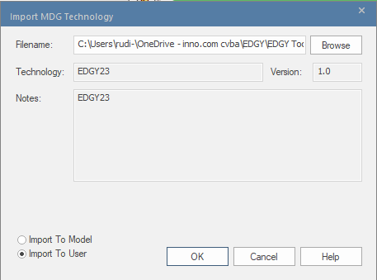
Remark: if you prefer evaluating SPARX4EDGY23 in the context of a single model, first open this model or create a new one. Then apply steps 1 and 2, and select the “Import To Model” option before you click on the OK button.

- Sparx will import the contents of “EDGY23 MDG.xml” and add this as a new MDG technology (or overwrite the existing version if this was already present). When this is successfully done, Sparx will show a confirmation dialog box. Click OK to finish the installation procedure.
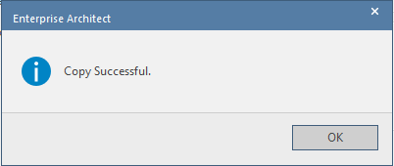
- Certain EDGY connector types are not UML-compliant for linking to another EDGY element, and if you select such types you might get an error message. You can continue to create this type of connector by de-selecting the 'Strict Connector Syntax' option on the 'Links' page of the 'Preferences' dialog (the 'Start > Appearance > Preferences > Preferences' ribbon option)
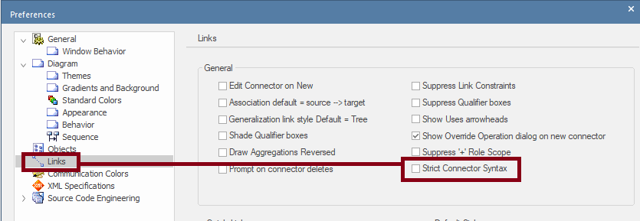
- You are now ready to start modeling with EDGY. There is no need to restart Sparx. The SPARX4EDGY23 Technology will remain active each time you launch Sparx.
Remark: You can deactivate and remove MDG technologies at any given time. It is also possible to work with a shared MDG Technology file, serving all linked Sparx instances on multiple computers. Check the Sparx documentation for more information.

SPARX4EDGY23 – CREATING A SAMPLE VIEWPOINT
SPARX4EDGY23 offers a toolbox containing the complete set of EDGY elements and relationships, which can be used on a dedicated diagram type. This can be created by executing the following steps:
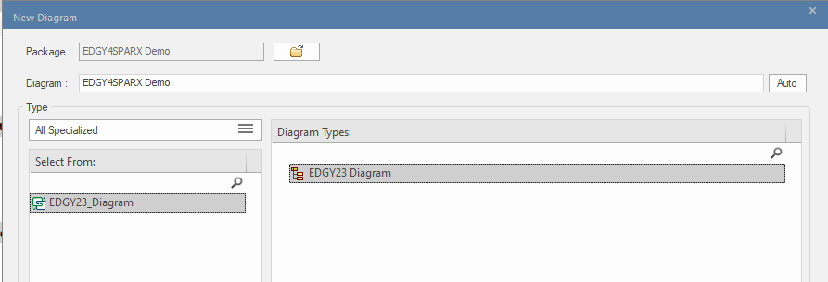
- Select the given package and add a new diagram
- On the dialog box “New Diagram”, select EDGY23_Diagram in the “Select From:” list and choose an “EDGY23 Diagram” viewpoint in the list “Diagram Types:”. You can narrow the search for this viewpoint by selecting the “All Specialized” option from the Type listbox
- Click OK to create the EDGY23 viewpoint
- Sparx will associate the appropriate toolbox with the given viewpoint. You are now ready to start modeling with EDGY. Have fun!
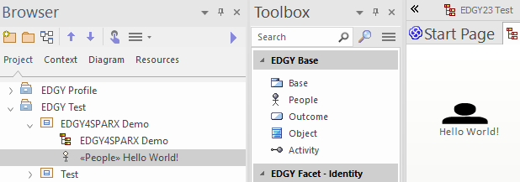
Remark: if you don’t want to show connector stereotype labels, deselect this option in the diagram options:
